Name;- Utsav Sharma . Id:- CZT240357

Task 2:- Configuring a Static Website With S3 And CloudFront

Steps:-

1. Go to the [AWS Management Console](https://aws.amazon.com/console/) and sign in.

2. Make sure you are in the region where you want to create your S3 bucket.for this project.

3.Navigate to the **S3** service in the AWS Management Console.

4.Click on **Create bucket**.

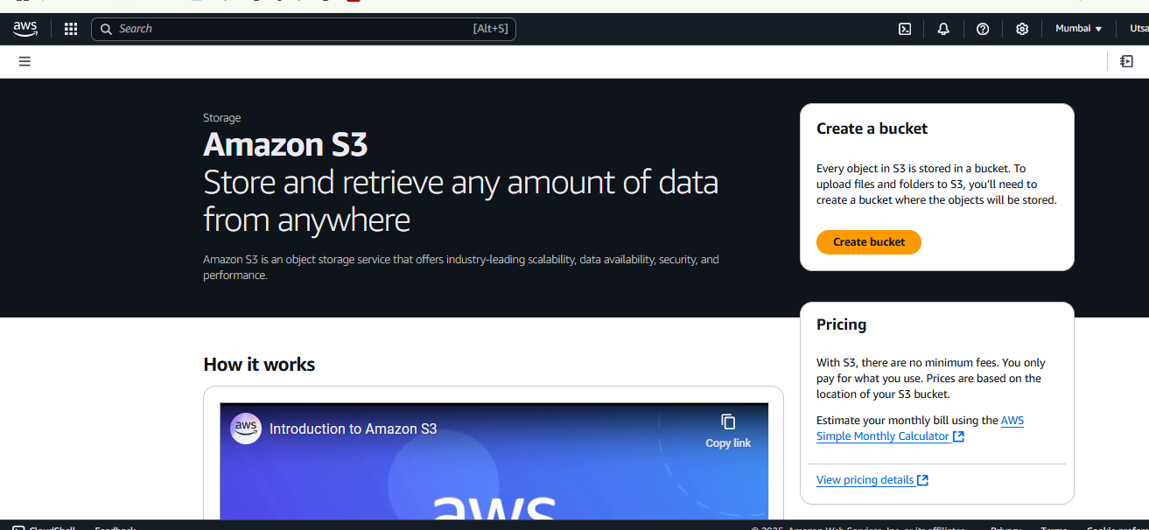

5. Provide a **unique name** for your bucket and select the AWS Region where you want to create the bucket

6. Select Acls enabled (see above Image)

7. **Block all public access** settings. By default, all options under this setting are checked to prevent public access.

8. Click **Create bucket** to finalize the bucket creation process.

9. To allow public access, you’ll need to add a bucket policy explicitly granting such permissions.

10. In the S3 dashboard, click on your newly created bucket’s name.

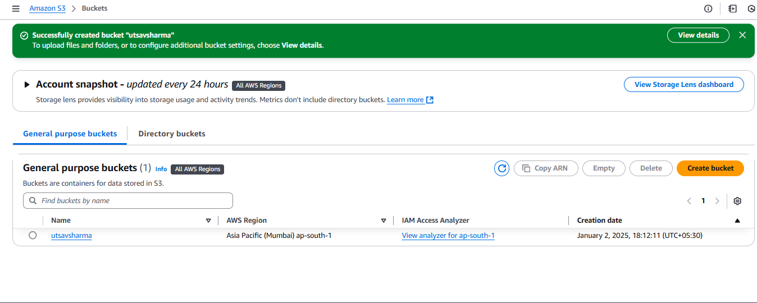

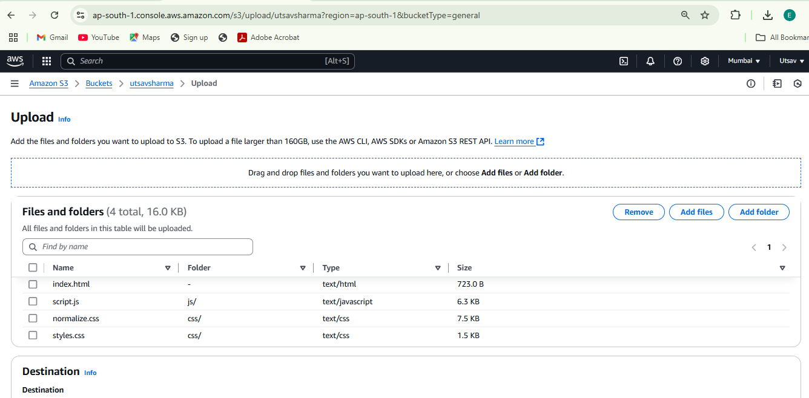

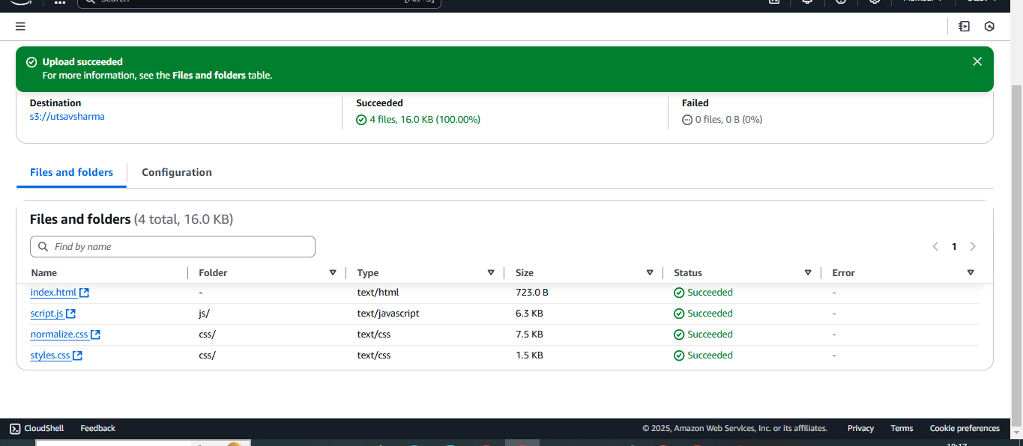

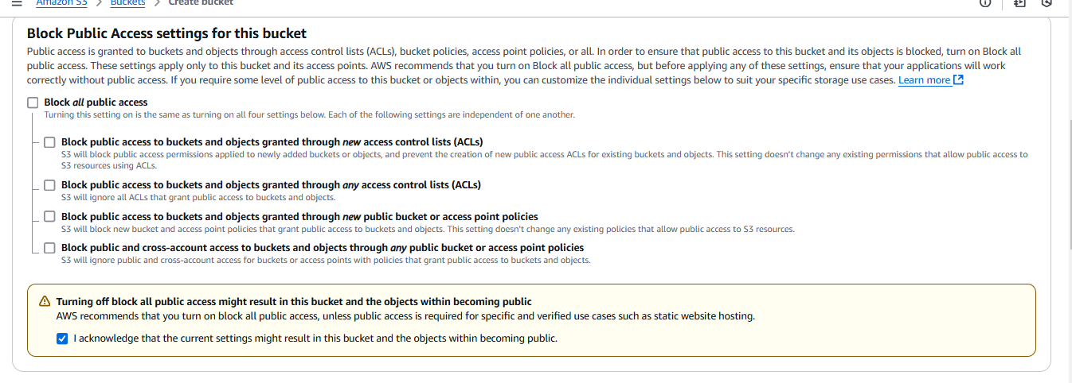

11.Go to the **Permissions** tab.

13. In the Policy editor, copy and paste the following and replace YOUR_BUCKET_NAME with the name of your S3 bucket

{

"Version": "2012-10-17",

"Statement": [

{

"Sid": "AddPerm",

"Effect": "Allow",

"Principal": "*",

"Action": "s3:GetObject",

"Resource": "arn:aws:s3:::YOUR_BUCKET_NAME/*"

}

]

}

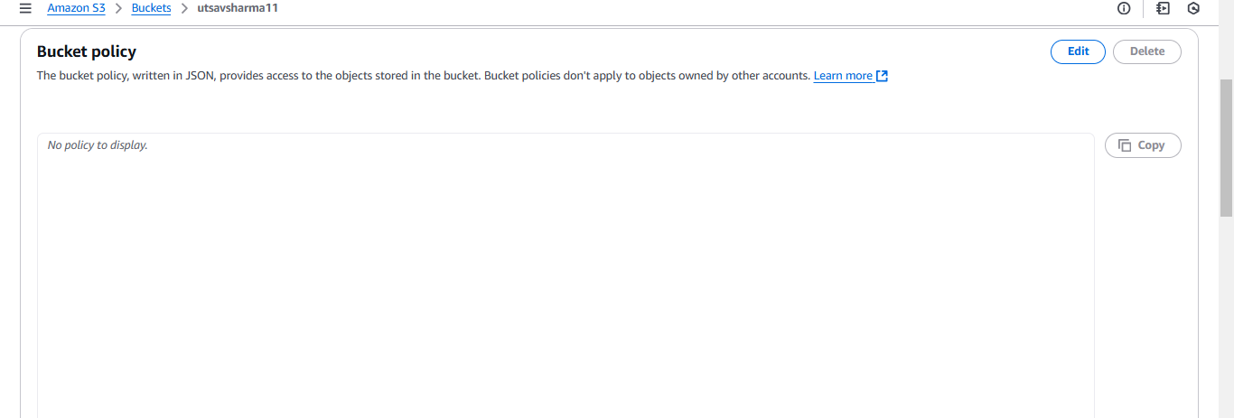

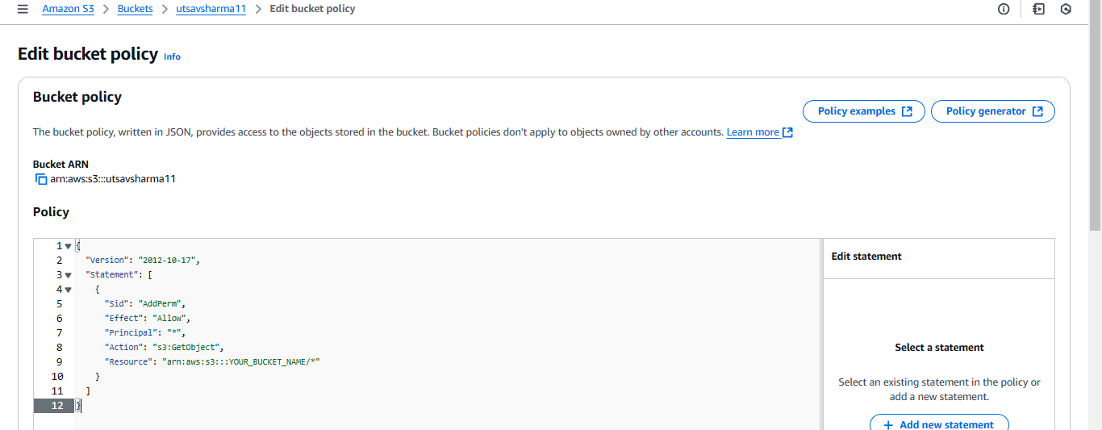

14. To save your bucket policy, at the bottom of the page, click Save changes.

The bucket overview page will load and you will see a notification that the policy has been edited.

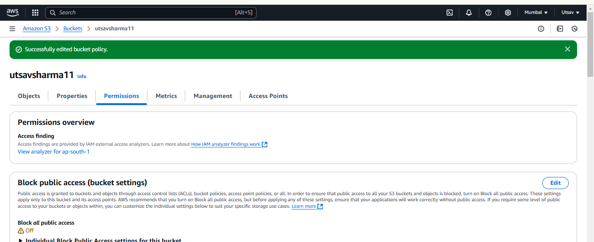

15. Let’s Enable static website hosting, Click on the Properties tab

17. Select Enable to enable static website hosting &

1. Choose **Host a static website**. Here, you’ll be prompted to enter:
   1. **Index document**: The name of your homepage document (e.g., index.html). This is the file served when visitors access the root URL of your website.
   2. **Error document** (optional): The name of the HTML file to show when an error occurs (e.g., error.html). This is not mandatory but recommended for handling HTTP errors gracefully.
2. (Optional) If you have a custom error document, fill in the **Error document** field.
3. Click **Save changes**.

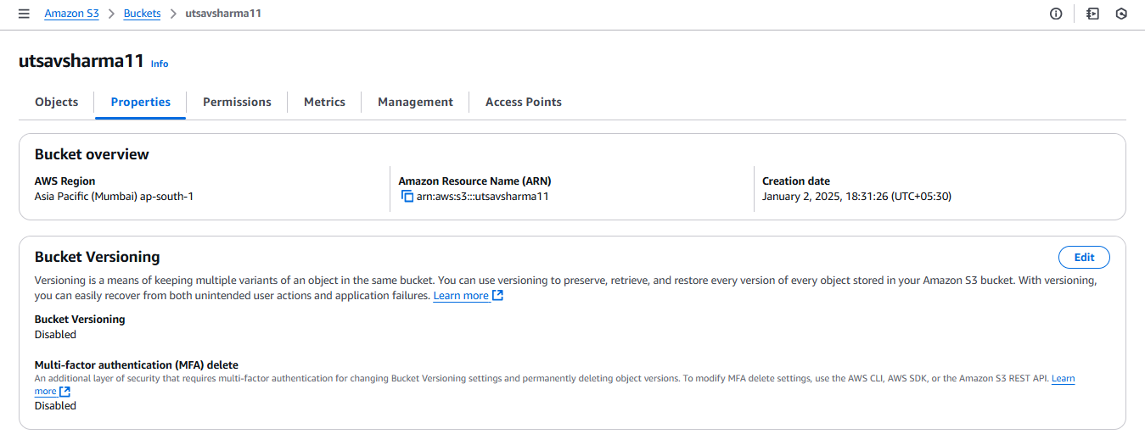

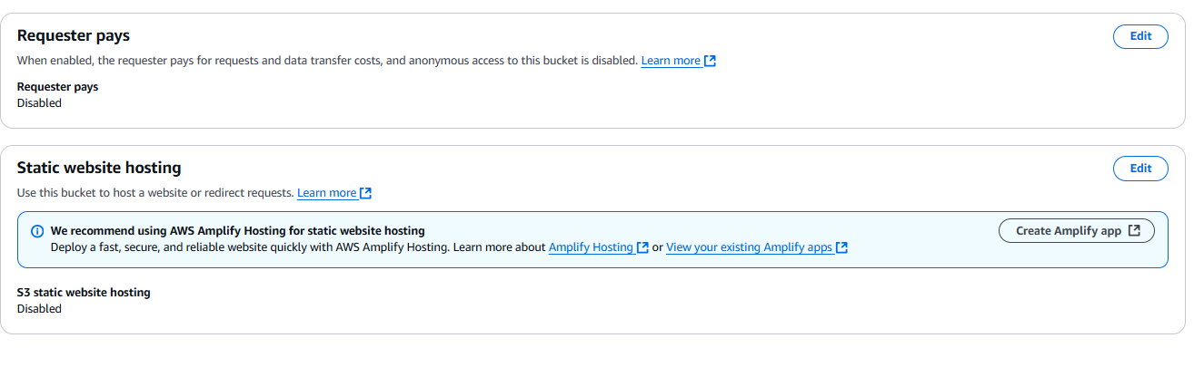

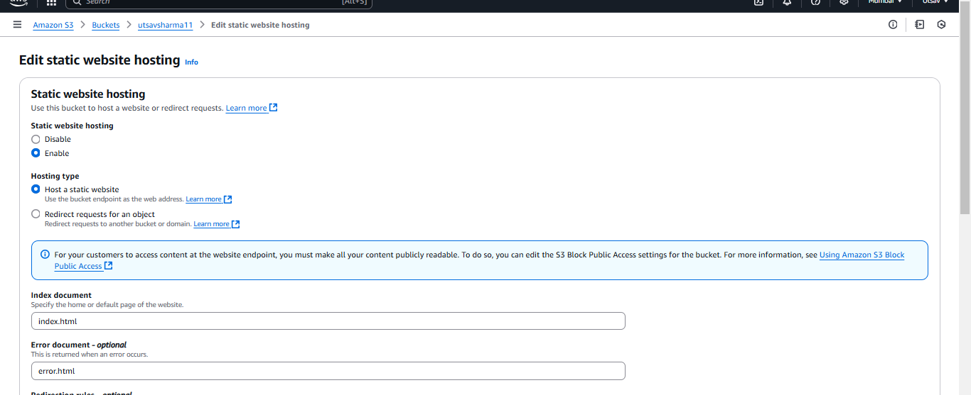

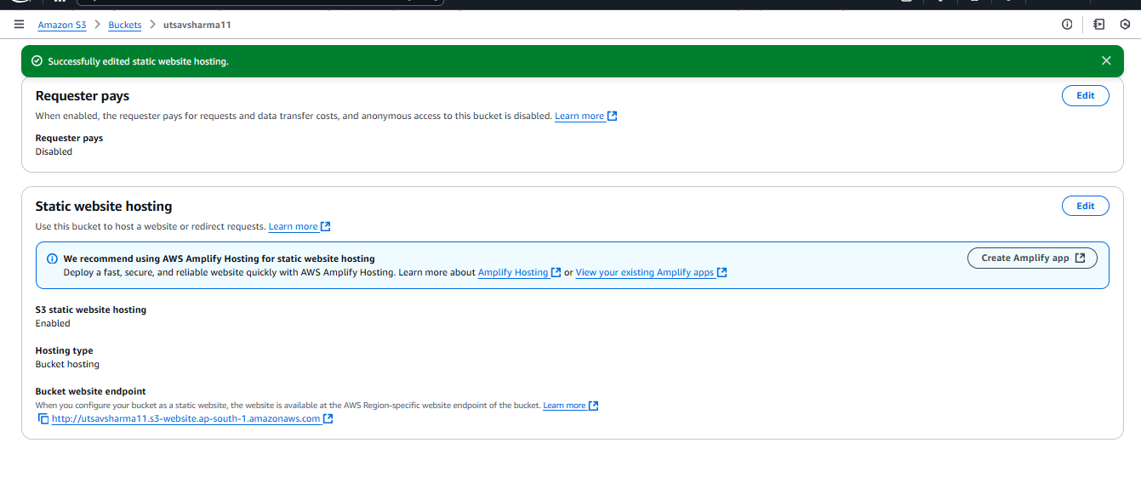

17. Upload the Website Files.

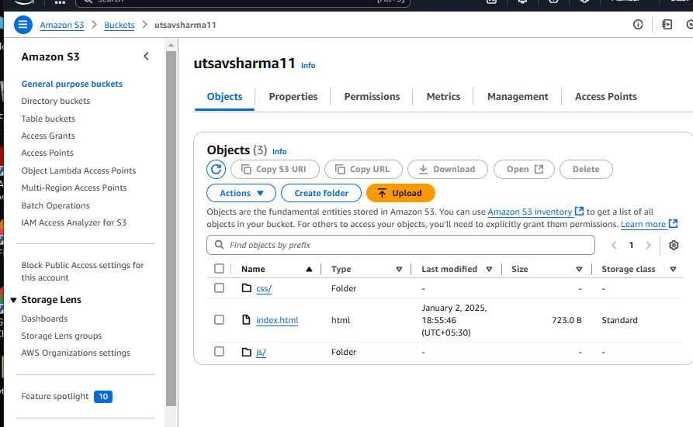

18 **Bucket website endpoint** URL. This URL is the public address of your static website.

19. Paste the endpoint into the address bar of a new browser tab.

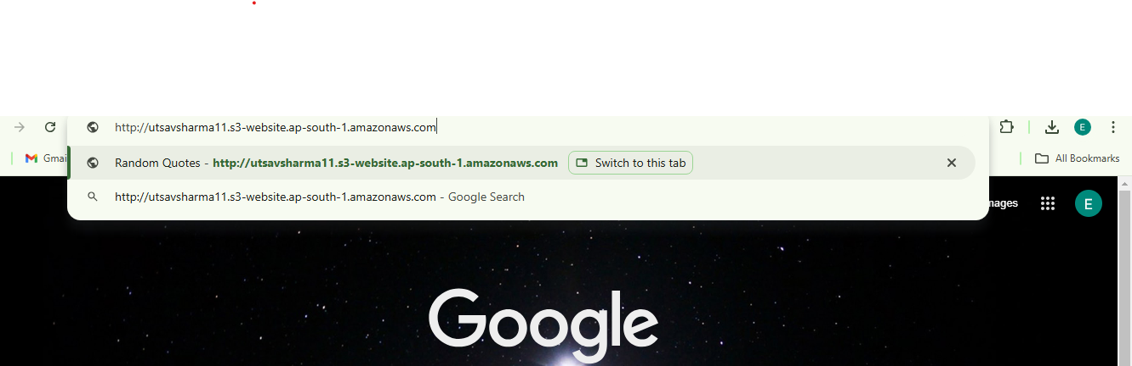

S3 output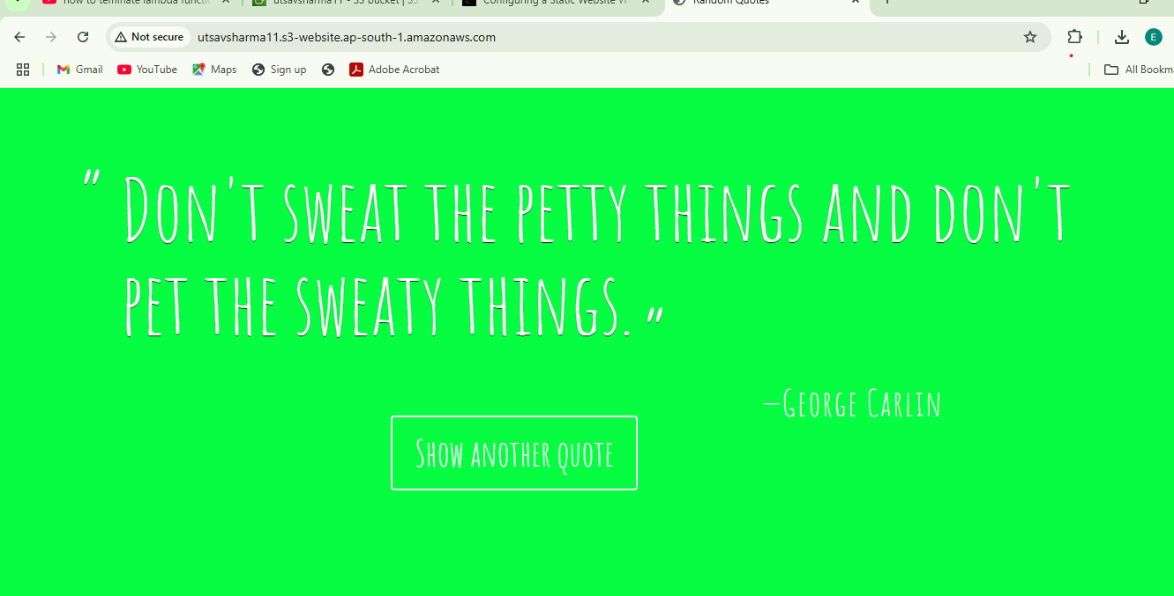

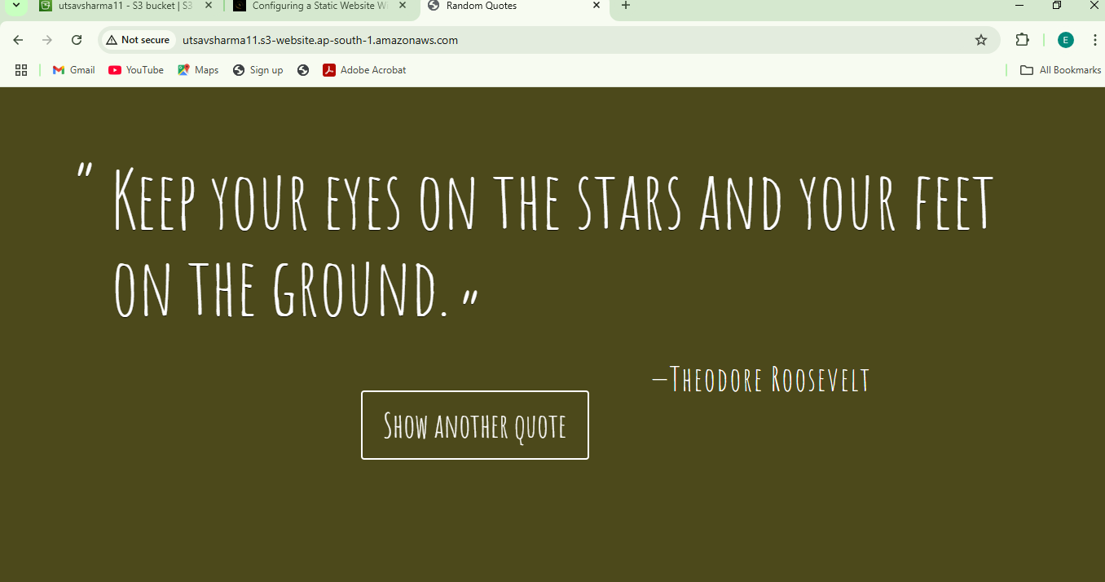

**CloudFront:-**

1. In the AWS Management Console search bar, enter CloudFront, and click the CloudFront result under Services: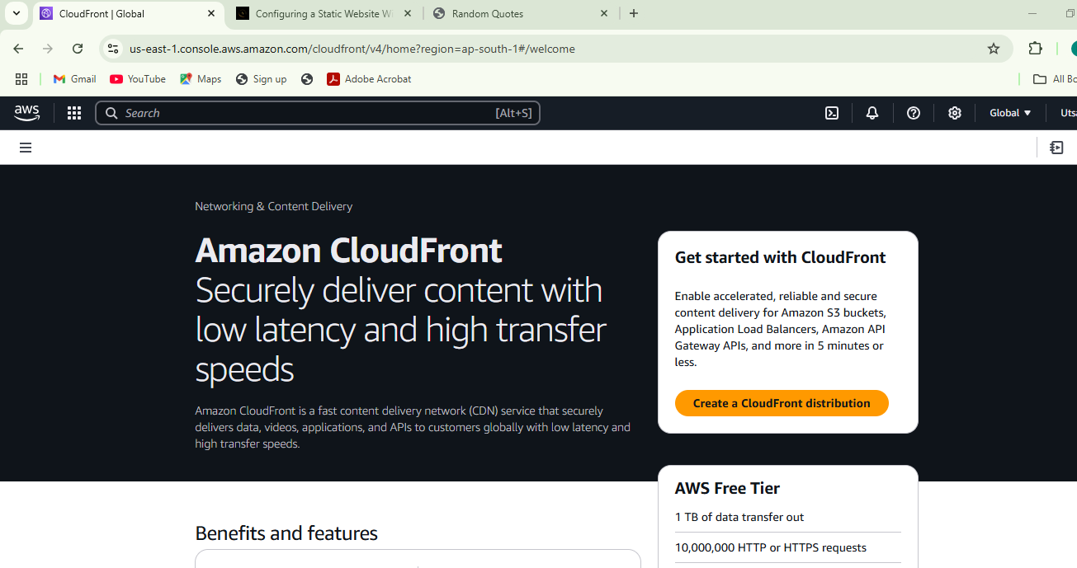 2. To start creating a distribution, click Create a CloudFront Distribution:

3. Under Origin, in the Origin Domain text-box, enter the Amazon S3 static website hosting endpoint that you created earlier:

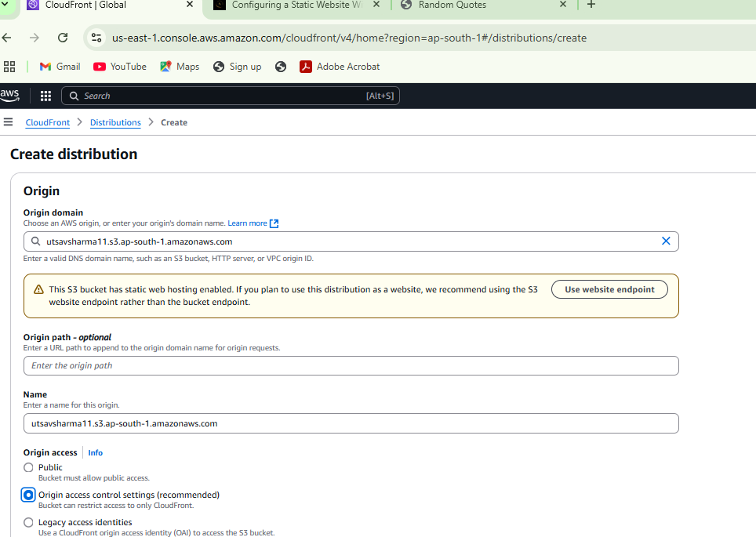

1. Under Origin, in the Origin access, select Origin access control settings and click Create new OAC:

5. Under Create control setting, enter the following values:

Name: by Default it will have

Signing behavior: Ensure Sign requests is selected

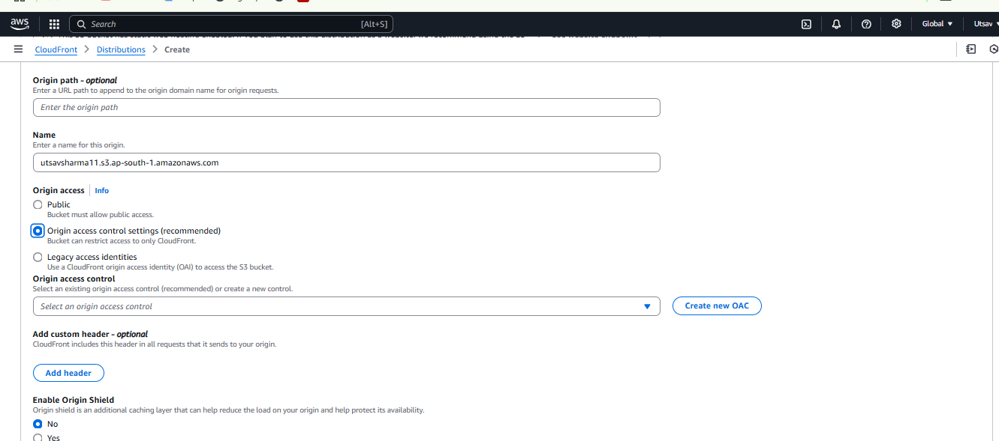

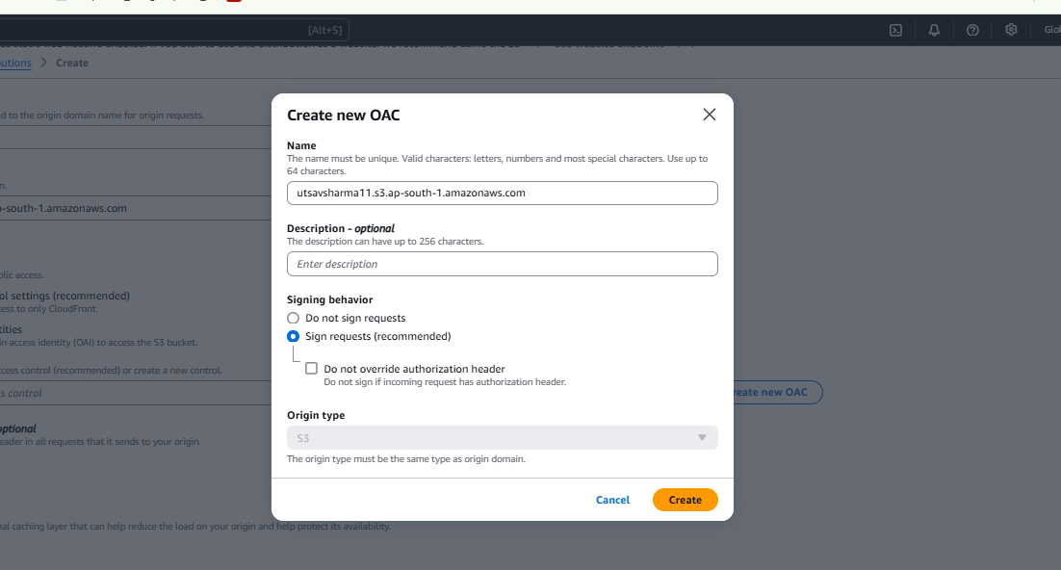

6. Select Do not enable security protections under Web Application Firewall (WAF):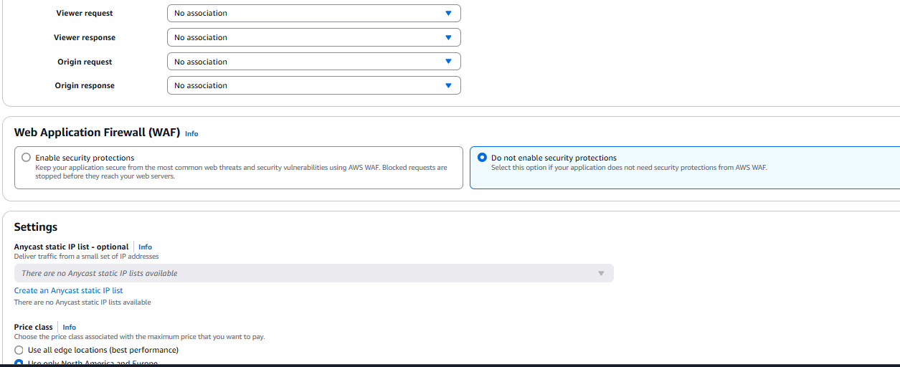

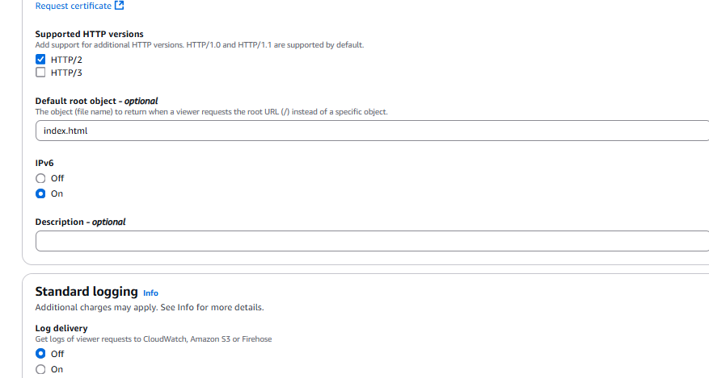

7 In the Default root object field, enter index.html.

8 To finish configuring your distribution, at the bottom of the page, click Create distribution:

9. Click Copy policy at the top of the page:

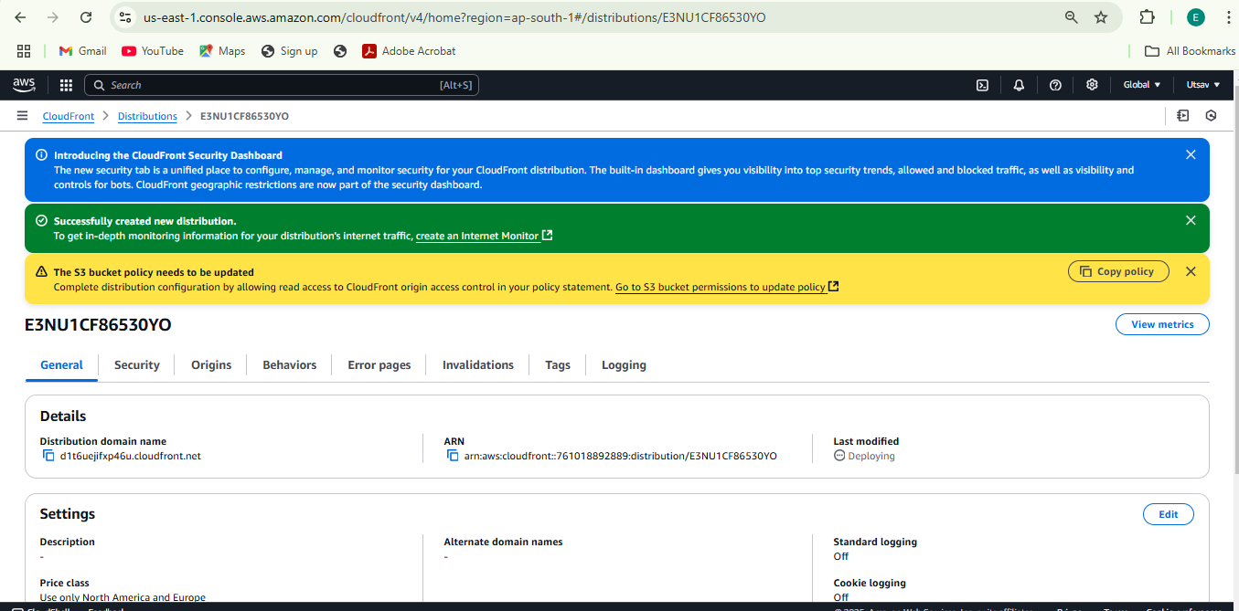

 10 To implement the policy, return to the bucket you created, click the Permissions tab, scroll down to the Bucket policy section, click Edit, paste the policy you copied, and click Save changes:

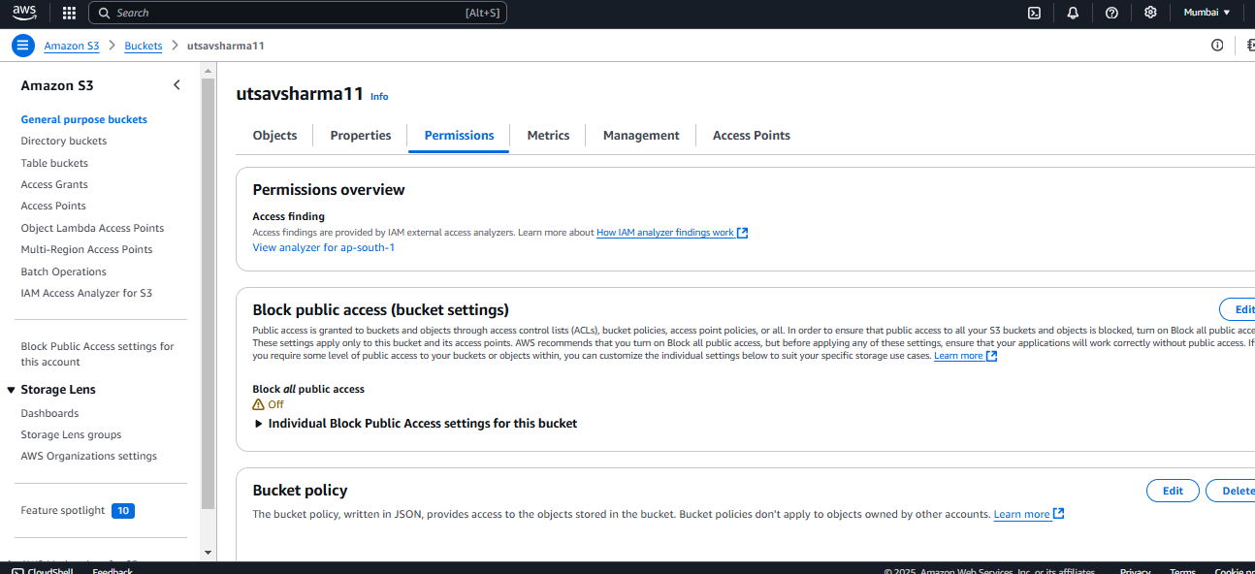

11 Go to Bucket policy & click on Edit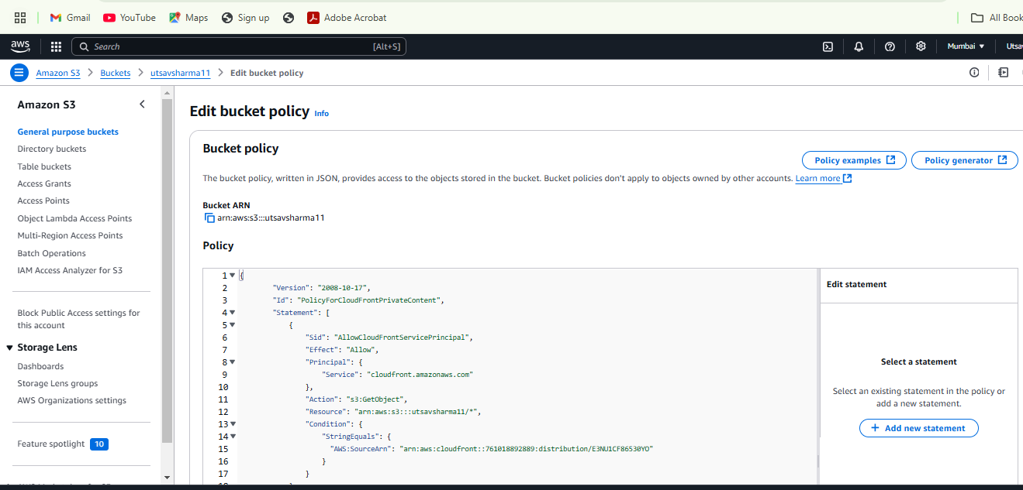

12. Update the Copied Policy from Cloudfront & click on Save Changes

13. Under the Block public access (bucket settings) section click Edit,

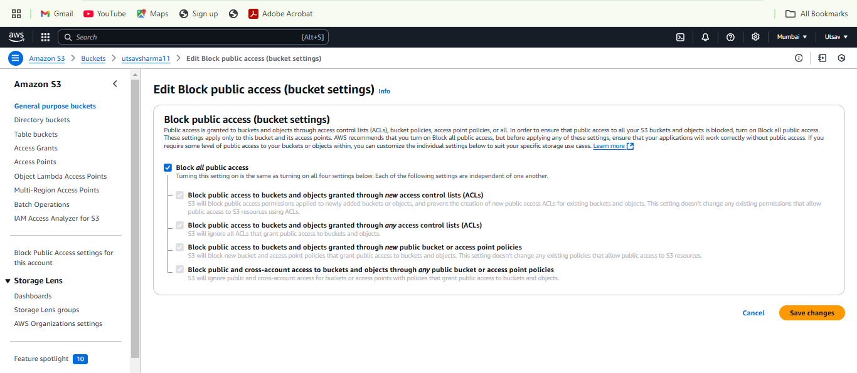

14 .The previous Bucket website endpoint will no longer work and will return a 403 error.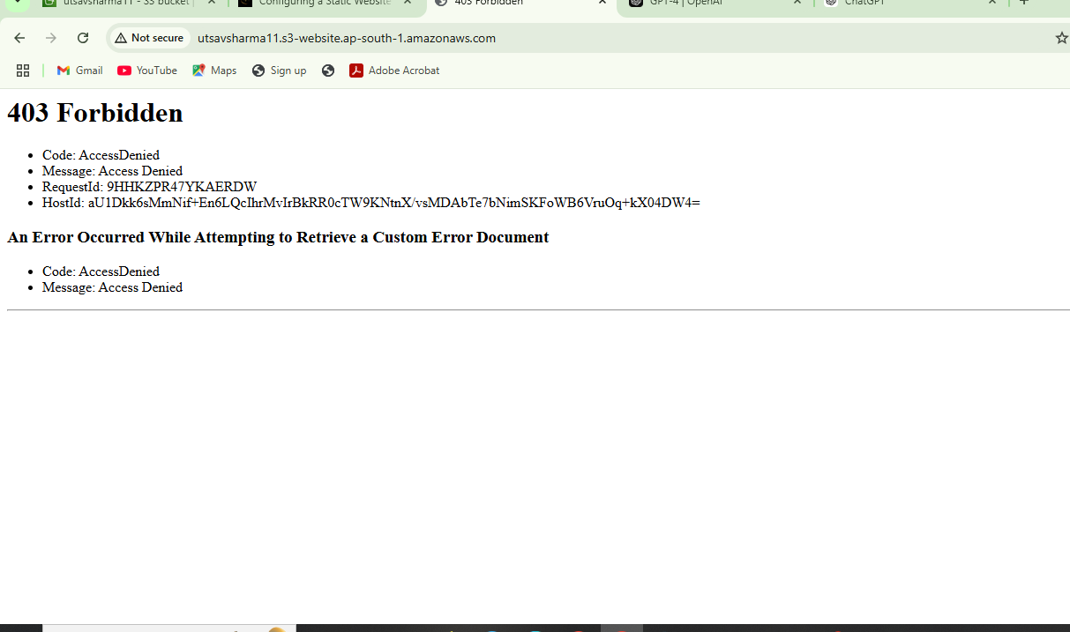

15. Return to the [CloudFront Distributions](https://us-east-1.console.aws.amazon.com/cloudfront/v4/home?region=us-west-2#/distributions) table:

16.Enter into Cloudfront Distributions to copy the Domain name

17. Paste the domain name into the address bar of a new browser tab.You will see the website that you uploaded to your Amazon S3 bucket display:

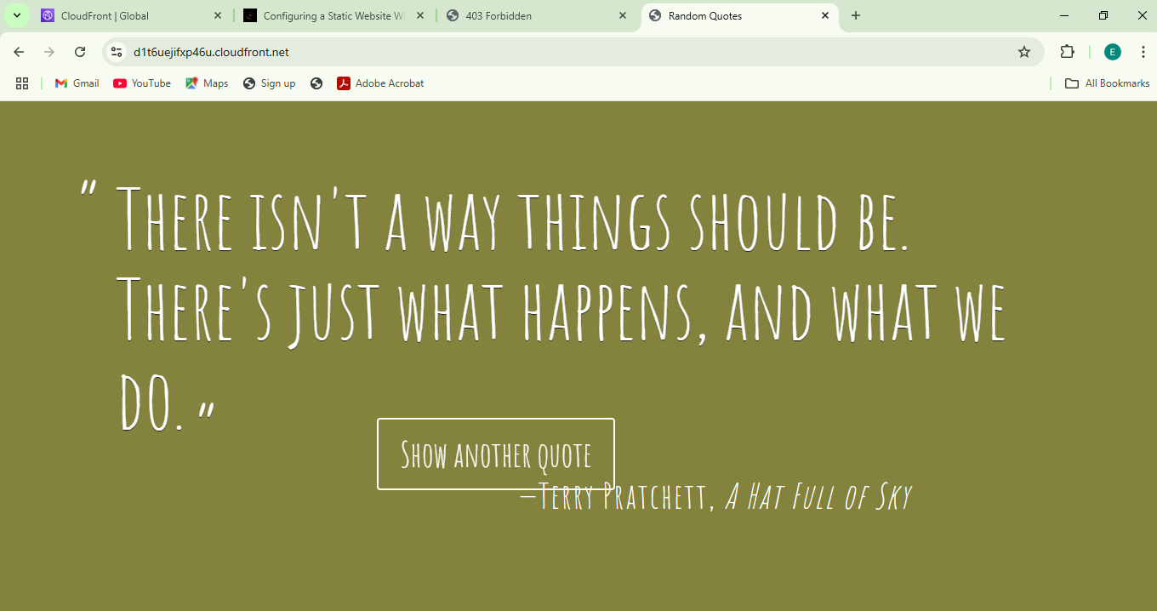

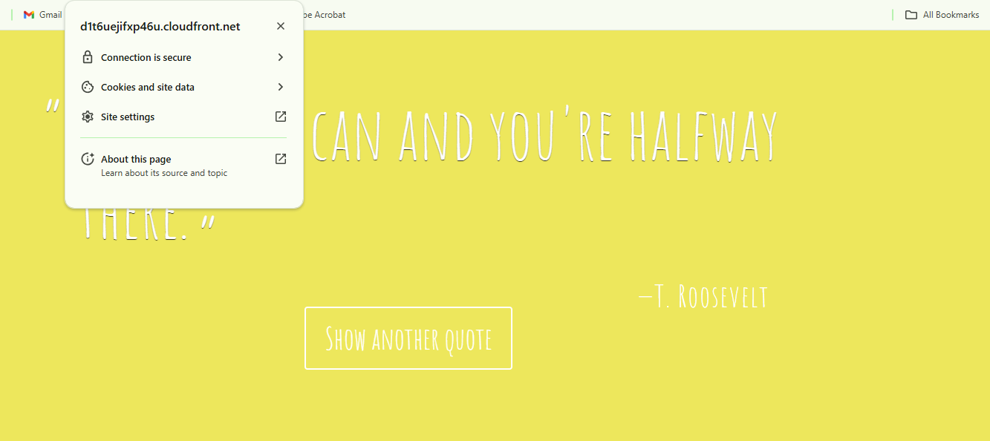

18) website link :- https://d1t6uejifxp46u.cloudfront.net